**MOVIE RECOMMEDATION SYSTEM USING MACHINE LEARNING**

**TABLE OF CONTENTS**

|  |  |  |
| --- | --- | --- |
| S.NO | CONTENT | PGNO |
| 1 | Introduction   * 1. Objective   2. Limitations   3. Outcomes   4. Applications | 1  1  2  2  3 |
| 2 | Problem Analytics  2.1 Problem Statement   * 1. Existing System | 4  4  4 |
| 3 | System Design | 6 |
| 4 | Architectural Diagram | 8 |
| 5 | Project Flow   * 1. Collecting Data   2. Preprocessing   3. Model | 10  10  12  13 |
| 6 | Tags and Vectors | 15 |
| 7 | Cosine Similarity | 16 |
| 8 | Implementation   * 1. Overview of Technologies   2. Codes   3. Output | 17  17  21  33 |
| 9 | Deployment | 34 |
| 10 | Conclusion | 36 |
| 11 | References | 37 |

**ABSTRACT**

## Recommender systems are vital components of today's digital landscape, leveraging sophisticated algorithms to predict user interests and offer product suggestions that align with their preferences. These systems are ubiquitous across renowned applications, particularly in e-commerce, serving as powerful manifestations of machine learning in driving sales and understanding customer behavior. Operating across diverse domains like books, movies, and music, recommendation systems analyze vast datasets to generate personalized suggestions tailored to individual preferences. Within movie recommendation systems, content-based filtering techniques, such as genre correlation, play a crucial role in suggesting films based on various criteria like genre, cast, crew, and plot themes. By discerning intricate correlations between different movie attributes, recommendation systems identify patterns in user preferences to match users with movies that resonate with their tastes. This approach not only enhances user experience and engagement but also fosters customer satisfaction and loyalty. Leveraging the power of machine learning and data analytics, recommendation systems enable businesses to deliver targeted recommendations, driving growth and success in the digital era.

**1. INTRODUCTION**

In today's digital landscape, recommender systems play a pivotal role in predicting user interests and suggesting product items that are likely to captivate their attention. These systems are extensively utilized by prominent applications and online retailers to drive sales and gain insights into customer behavior. The core challenge lies in developing effective recommendation algorithms capable of accurately tailoring suggestions across diverse content types such as books, movies, music, and more. Specifically, this problem focuses on implementing a content-based filtering approach with genre correlation to enhance the movie recommendation process. By leveraging movie metadata including genre, cast, and crew details, the aim is to devise algorithms that can intelligently match user preferences with relevant content. However, amidst the abundance of data, challenges such as data sparsity, scalability, and ensuring personalized recommendations present significant hurdles. Therefore, the objective is to devise robust recommendation systems that not only enhance user experience but also drive engagement and sales for online retailers.

* 1. **OBJECTIVE:**

**Dataset Utilization:** Employ the TMDB dataset encompassing extensive movie-related information, including titles, ratings, runtime, genre, cast, and crew, along with web-scraped movie reviews from TMDB for sentiment analysis.

**Architecture Design:** Develop a robust system architecture consisting of an input module, frontend, and backend, enabling efficient user interaction and data processing.

**Algorithm Implementation:** Implement the K Nearest Neighbors (KNN) algorithm to analyze movie data using the vector space model, generating a list of movies similar to user-searched queries.

**Recommendation Generation:** Utilize the KNN output as input for the Cosine Similarity algorithm to rank and reorder the list of similar movies based on user reviews and ratings, providing personalized and relevant movie recommendations.

**User Interface Enhancement:** Enhance the frontend of the recommendation system with HTML and JavaScript to provide a seamless user experience, displaying movie posters, cast details, sentiment-analyzed reviews, and suggested films.

**Evaluation and Validation:** Evaluate the effectiveness and accuracy of the recommendation system through rigorous testing and validation processes, ensuring that the generated recommendations align with user preferences and expectations.

* 1. **Limitations:**

The effectiveness of traditional recommendation systems like collaborative filtering and content-based filtering is hindered by their dependence on prior user activity, which poses challenges for new or inactive users. Additionally, the accuracy of sentiment analysis from tweets, a key component in enhancing recommendations, is heavily reliant on the availability and quality of data. Noisy or irrelevant content in tweets can significantly impact the system's performance. Moreover, the system's limited coverage of old movies, due to the scarcity of tweets, restricts its applicability to users interested in older films. Scalability issues may arise as the system fetches tweets from Twitter, potentially straining resources and affecting performance with increasing user base and tweet volume. Furthermore, biases in user preferences or sentiment expressed in tweets can limit the system's effectiveness, leading to recommendations that may not be representative of all users' preferences. Despite leveraging sentiment analysis, the system may struggle to address the cold start problem for new or less popular movies, lacking sufficient data or sentiment analysis for accurate recommendations. Finally, ethical considerations surrounding user privacy and consent in analyzing tweets pose challenges, potentially limiting data availability for analysis.

**1.3 Outcomes:**

## The development of a movie recommendation system based on various parameters, machine learning, and vectorization techniques has yielded significant outcomes. By incorporating diverse factors beyond mere user activity history, the system delivers more comprehensive and tailored recommendations, thereby enhancing user satisfaction and engagement. Through machine learning algorithms and vectorization, the system can discern intricate patterns and correlations in movie attributes and user preferences, leading to improved recommendation accuracy. Despite potential limitations regarding older movie data availability, the system remains adept at providing a wide array of recommendations, particularly for newer releases, thereby catering to users seeking up-to-date content. Furthermore, the successful implementation of this approach underscores its scalability, ensuring robust performance even with expanding user bases and data volumes. By leveraging a multiplicity of parameters, the system mitigates biases inherent in traditional recommendation algorithms, thereby fostering inclusivity and reflecting diverse user tastes. While it may not entirely eliminate the cold start problem, the system's ability to incorporate multiple parameters enables it to offer informed recommendations even for new or less popular movies, thereby enriching the user experience. In sum, these outcomes collectively contribute to a more sophisticated, personalized, and engaging movie recommendation system, enriching the overall user experience.

**1.4 Applications**:

The utilization of content-based movie recommendation systems, developed with the Dash library in Python, spans various sectors and platforms. Entertainment giants like Netflix, Amazon Prime, and Hulu can enhance user satisfaction by providing personalized movie suggestions tailored to individual preferences. Similarly, e-commerce platforms such as Amazon can improve the shopping experience by suggesting movies based on browsing history and purchase behavior. Social media platforms like Facebook and Instagram have the potential to boost user engagement by incorporating movie recommendation features driven by user interests and interactions**.** Movie review websites likeTMDB and Rotten Tomatoes can offer tailored recommendations, considering historical ratings and reviews. Mobile apps like Flixster and Letterboxd can enrich user experience by providing personalized movie suggestions. Moreover, companies in the movie industry can utilize these systems for targeted advertising and marketing, while researchers and analysts can study audience trends and preferences. Educational platforms offering film-related content can also benefit by recommending relevant movies to learners based on their interests. Overall, the integration of content-based movie recommendation systems via the Dash library facilitates a more personalized and engaging movie-watching experience across various platforms and industries.

**2. Problem Analysis**

**2.1. Problem Statement:**

The movie recommendation system faces key challenges: understanding diverse user preferences accurately, accessing high-quality and relevant data, ensuring scalability to handle growing user and movie databases, addressing the cold start problem for new users and less popular movies, selecting and optimizing recommendation algorithms, respecting user privacy, defining appropriate evaluation metrics, and implementing ethical data practices. These challenges require a multidisciplinary approach, combining data science, machine learning, software engineering, and domain expertise, to deliver personalized experiences and foster business growth while ensuring user satisfaction.

**2.2. Existing System:**

Existing movie recommendation systems can be broadly categorized into two main types: collaborative filtering and content-based filtering. Collaborative filtering operates by analyzing the preferences and actions of similar users to suggest movies. It can be further classified into user-based collaborative filtering, where recommendations are based on the preferences of users with similar tastes, and item-based collaborative filtering, which recommends movies similar to ones previously liked by the user. On the other hand, content-based filtering recommends movies by examining the intrinsic features and attributes of the films themselves, such as genre, cast, director, and plot summaries. Unlike collaborative filtering, content-based filtering does not rely on user interactions but rather on the characteristics of the movies. These two approaches serve as the foundation for most movie recommendation systems, each offering distinct advantages and limitations in providing personalized movie suggestions to users.

Present recommendation systems like those employed by Netflix and Amazon Prime predominantly rely on collaborative filtering techniques. While collaborative filtering is widely used, its accuracy can be limited, particularly when user data is sparse or when users have diverse tastes. In contrast, our project focuses on leveraging content-based filtering techniques, which analyze the intrinsic characteristics of movies rather than relying solely on user interactions. By considering attributes such as genre, cast, plot, and themes, content-based filtering can offer more accurate and personalized recommendations, especially in scenarios where collaborative filtering struggles. This shift allows us to provide users with recommendations that better align with their individual preferences, enhancing the overall user experience and satisfaction. Below are some recommendations from Netflix, you can see they are not up to the mark.

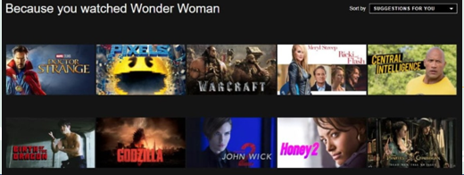

Fig 2.1: Existing System



Fig 2.2 : Existing System

**3.** **System Design**

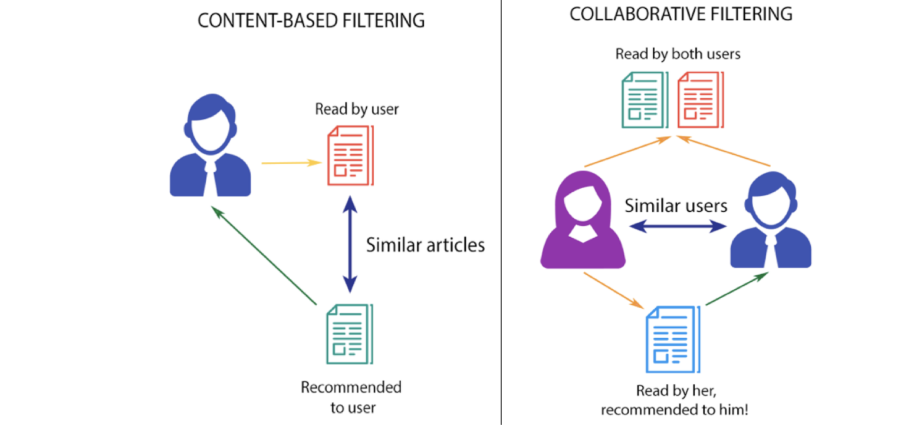

Fig 3.1: Types of Recommendation Systems

**Data Collection:** The system needs access to a comprehensive data set containing information about movies, users, ratings, and other relevant features. This data can be sourced from various sources such as movie databases, user interactions, and external APIs.

**Data Preprocessing:** Raw data obtained from different sources may need to be cleaned, normalized, and standardized to ensure consistency and quality. This step involves handling missing values, removing duplicates, and encoding categorical variables.

**Feature Extraction**: Extracting relevant features from the dataset is crucial for building accurate recommendation models. Features could include movie genres, cast and crew information, user preferences, historical ratings, and contextual data.

**Model Selection**: Choose appropriate recommendation algorithms based on the nature of the data and the desired outcome. This could involve collaborative filtering, content-based filtering, matrix factorization techniques, or hybrid approaches combining multiple algorithms.

**Model Training**: Train the selected recommendation model using historical user-item interactions and relevant features extracted from the dataset. This step involves optimizing model parameters, evaluating performance metrics, and fine-tuning algorithms.

**Real-time Processing:** Implement mechanisms for real-time data processing and recommendation generation to ensure timely and dynamic responses to user queries and interactions. This may involve deploying streaming data processing frameworks or event-driven architectures.

**Scalability and Performance:** Design the system to handle large volumes of data and user requests efficiently. This could involve distributed computing frameworks, cloud-based infrastructure, and caching mechanisms to improve response times and scalability.

**Personalization and Diversity:** Incorporate techniques for personalizing recommendations based on individual user preferences while ensuring diversity and serendipity in the suggested content. This could involve incorporating user feedback loops, diversity metrics, and reinforcement learning algorithms.

**User Interface:** Develop an intuitive and user-friendly interface for presenting recommendations to users across different platforms such as web applications, mobile apps, or smart TVs. The interface should facilitate easy navigation, browsing, and interaction with recommended content.

**Monitoring and Evaluation:** Implement monitoring and evaluation mechanisms to continuously assess the performance and quality of the recommendation system. This involves tracking key metrics such as click-through rates, conversion rates, user engagement, and satisfaction levels.

**4 . Architecture Diagram of Movie Recommendation system**

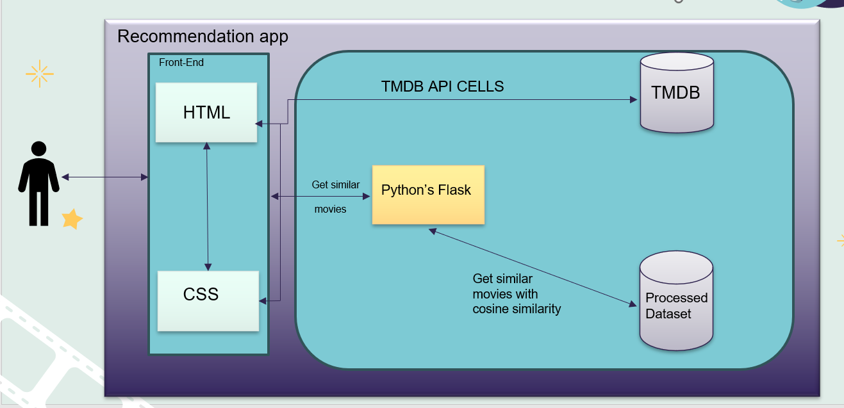

Fig 4.1 : Architecture

The architecture of a movie recommendation system typically consists of several interconnected components that work together to provide personalized movie suggestions to users. Here's an overview of the key components and their roles in the system.

Here’s a breakdown of the process:

**Front End:** This refers to the user interface of the application, where users interact with the system. It could be a website or a mobile app.

**TMDB API:** TMDB stands for The Movie Database, a popular website that provides data about movies, TV shows, and actors https://www.themoviedb.org/. The recommendation system retrieves information about movies from the TMDB database through its API (Application Programming Interface). An API allows two software programs to communicate with each other.

**Processed Dataset:** This refers to a collection of movie data that has been prepared for use by the recommendation algorithm. It likely includes information about the movies themselves, such as titles, actors, genres, and user ratings.

**Python’s Flask:** This could refer to a web framework written in Python that helps developers create web applications. In this case, it might be being used to develop the backend of the recommendation app. Get Similar Movies: This refers to the core functionality of the recommendation system. The system uses an algorithm to find movies that are similar to a particular movie that a user has indicated they like. There are different algorithms that can be used for this purpose. Cosine similarity is one technique that can be used to measure how similar two items are based on the features they share.

## In essence, when a user interacts with the app, the front end sends a request to the back end to find similar movies using the TMDB API. The backend uses an algorithm, possibly cosine similarity, to compare movies in the processed dataset to the movie the user liked to find similar ones. The recommendations are then presented to the user through the front end**.**

**5. Project Flow**

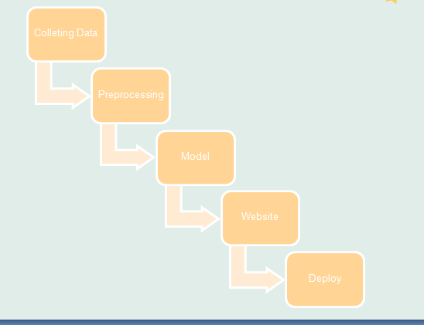

Fig 5.1 : Project Flow

## **5.1 Collecting data :**

## Creating a movie recommendation system using data from Kaggle can be an exciting project. Kaggle offers various datasets related to movies, including information about movie ratings, genres, actors, directors, and more. Here's a step-by-step guide on how you can build a simple movie recommendation system using such data.

**Data Collection:** Start by selecting an appropriate dataset from Kaggle that contains relevant information about movies, such as ratings, genres, cast, crew, etc. Some popular datasets include Movie Lens and IMDb datasets.

**Data Preprocessing:** Clean the dataset by handling missing values, removing duplicates, and formatting the data appropriately. You may also need to merge multiple datasets if necessary.

**Feature Engineering:** Extract relevant features from the dataset that can be used to build the recommendation system. For example, you can create features such as movie genres, actors, directors, release year, average rating, etc.

**Collaborative Filtering:** Implement collaborative filtering techniques such as user-based or item-based collaborative filtering. Collaborative filtering recommends items based on the preferences of similar users or the similarity between items.

**Content-Based Filtering:** Implement content-based filtering techniques that recommend items similar to those a user has liked in the past. This can be based on features such as movie genres, actors, directors, etc.

**Hybrid Approaches:** Combine collaborative filtering and content-based filtering techniques to build a hybrid recommendation system that leverages the strengths of both approaches.

**Evaluation:** Evaluate the performance of your recommendation system using metrics such as accuracy, precision, recall, etc. You can split the dataset into training and testing sets to evaluate the system's performance.

**Deployment:** Deploy your recommendation system to a platform where users can interact with it, such as a web application or a mobile app.

**Feedback Loop:** Implement a feedback loop mechanism where user feedback is collected and used to improve the recommendation system over time. This can be done by collecting user ratings or explicit feedback on recommended items.

**Monitoring and Maintenance:** Continuously monitor the performance of the recommendation system and update it as necessary with new data or improvements to the algorithm

**5.2 Preprocessing :**

Preprocessing the data for a movie recommendation system involves cleaning and transforming the raw dataset into a format suitable for modeling. Here are the steps you can follow for preprocessing:

**Load the Dataset:** Load the movie dataset from Kaggle into your programming environment. This could be a CSV file, JSON file, or any other format.

**Handle Missing Values:** Check for missing values in the dataset and decide on an appropriate strategy to handle them. You may choose to remove rows with missing values, impute missing values using mean or median, or use more advanced techniques like predictive imputation.

**Data Cleaning:** Perform any necessary data cleaning steps such as removing duplicates, correcting inconsistencies in the data, and converting data types if needed.

**Feature Selection:** Decide which features are relevant for your recommendation system. Common features include movie title, genre, release year, director, actors, ratings, and user ratings.

**Feature Engineering:** Extract additional features from the dataset that can be useful for modeling. For example, you can extract the year from the release date, create binary variables for movie genres, or calculate aggregate statistics like average ratings.

**Normalization/Scaling:** If necessary, normalize or scale numerical features to a similar range to prevent features with larger scales from dominating the model.

**Encoding Categorical Variables:** Encode categorical variables such as movie genres, directors, and actors into numerical representations using techniques like one-hot encoding or label encoding.

**Split Data:** Split the dataset into training and testing sets. The training set will be used to train the recommendation system, while the testing set will be used to evaluate its performance.

**Save Preprocessed Data:** Save the preprocessed data to a file or database for easy access during modeling and evaluation stages.

Exploratory Data Analysis (Optional): Perform exploratory data analysis to gain insights into the dataset and understand the relationships between different features. This can help you make informed decisions during preprocessing and modeling stages.

**5.3 Model :**

Building a movie recommendation system involves choosing and implementing a suitable model that can provide personalized movie recommendations based on user preferences. Here are several popular models for movie recommendation systems:

**Collaborative Filtering:**

User-Based Collaborative Filtering: This approach recommends items to a user based on the preferences of users who are similar to them. It calculates similarities between users based on their past interactions with items (e.g., movie ratings) and recommends items that similar users have liked.

Item-Based Collaborative Filtering: In this approach, similarity between items (movies) is calculated based on the ratings given by users. Items that are similar to those liked by the user are recommended.

Matrix Factorization: This method decomposes the user-item interaction matrix into lower-dimensional matrices to capture latent features. Techniques like Singular Value Decomposition (SVD) and Alternating Least Squares (ALS) are commonly used for matrix factorization.

**Content-Based Filtering:**

This approach recommends items similar to those the user has liked in the past. It relies on the content/features of items (e.g., movie genres, actors, directors) and computes similarity between items based on these features. Cosine similarity or Euclidean distance can be used to measure similarity.

**Hybrid Models:**

Combining Collaborative and Content-Based Filtering: Hybrid models combine the strengths of collaborative and content-based filtering approaches to provide more accurate recommendations.

For example, the recommendations from both approaches can be weighted and combined to generate final recommendations.

**Factorization Machines:** Factorization machines combine collaborative filtering and feature engineering by modeling interactions between features. They can handle sparse and high-dimensional data efficiently

Creating a Movie Recommendation System Website with Dash Choose a Web Framework Select Dash, a Python framework for building analytical web applications. Dash offers simplicity and flexibility, ideal for integrating data-driven components like movie recommendation systems. Set Up the Development

**Environment:** Install Python and the necessary libraries, including Dash, Pandas, and Scikit-learn. Utilize a code editor like Visual Studio Code or PyCharm for development

**Design the User Interface:** Craft the website's layout and interface using Dash's declarative syntax, which combines Python with HTML and CSS. Utilize Dash components and styling options for responsive design and user-friendly visuals. Backend Development: Develop the backend logic using Python and Dash callbacks. Define routes and handle user interactions, including authentication if required, within the Dash application.

**Integrate the Recommendation System**: Incorporate the movie recommendation model into the Dash application. Utilize Python functions to call the recommendation model or directly integrate the model's code within the application.

**Database Integration:** Set up data storage using libraries like Pandas or SQLite within the Dash application. Store user data, movie information, and preferences within the application's environment.

**User Registration and Authentication:** Implement user registration and authentication features if needed using Dash's authentication libraries or integrating with external providers. Personalized Recommendations: Display personalized movie recommendations to users based on their interactions and preferences. Utilize Dash callbacks to dynamically update recommendations based on user input.

**Testing:** Thoroughly test the website's functionality using Dash's testing utilities and Python testing frameworks. Conduct both unit tests and end-to-end tests to ensure reliability and identify any issues

# **6. Tags and Vectors:**

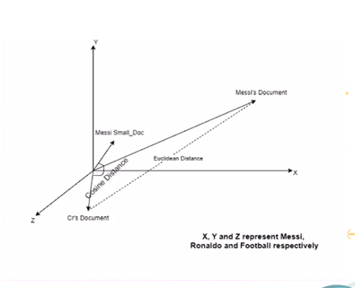

Fig 6.1 : Tags and Vectors

**Tags:**

Tagging is very useful for users to figure out other users with similar interests within a given category. Users with similar interests might post similar tags and similar resources might have similar tags posted to them. Collaborative filtering is widely used in automatic prediction system.

**Vectors:**

One simple way is to compute a user vector as an average of the movie vectors that they've seen. These user vectors can represent the user's profile of movie preferences.

# 

# **7. How Cosine Similarity works**

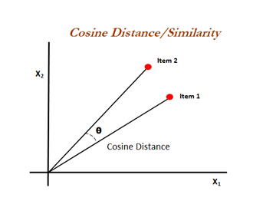

Fig 7.1 : Cosine Similarity

Cosine similarity is a metric used to measure how similar the documents are irrespective of their size. Mathematically, it measures the cosine of the angle between two vectors projected in a multi-dimensional space. The cosine similarity is advantageous because even if the two similar documents are far apart by the Euclidean distance (due to the size of the document), chances are they may still be oriented closer together. The smaller the angle, higher the cosine similarity

**8 . Implementation:**

**8.1 Overview of Technologies :**

## **Python :**

Python is a versatile and high-level programming language known for its simplicity and readability, making it an excellent choice for both beginners and experienced developers. Developed by Guido van Rossum and first released in 1991, Python has gained widespread popularity due to its extensive standard library, which includes modules for tasks ranging from web development and data analysis to scientific computing. Its elegant and clean syntax, based on indentation, promotes code readability and maintainability. Python supports multiple programming paradigms, including object-oriented, functional, and imperative programming, and it has a vast and active community that continually contributes to its development and the creation of third-party libraries, making it a go-to language for a wide range of applications, from web applications and automation scripts to machine learning and data science

## **Jupyter Notebook:**

A Jupyter Notebook is a versatile interactive computing environment that facilitates data analysis, visualization, and documentation. It offers a flexible interface where users can seamlessly integrate executable code, formatted text using Markdown syntax, and raw content. The notebook is organized into cells, with code cells allowing direct execution of code and markdown cells enabling the creation of narrative explanations with rich formatting. Users can generate plots and visualizations inline, leveraging libraries like Matplotlib and Seaborn. Additionally, Jupyter Notebooks support integration with external libraries and tools, enhancing their capabilities for data manipulation and analysis. The ability to save and share notebooks in various formats, along with their collaborative features, makes them invaluable for data scientists, researchers, and educators in exploring and sharing insights from their work.

**Pycharm:**

PyCharm stands as a versatile and powerful Integrated Development Environment (IDE) specifically designed for Python programming. Developed by JetBrains, PyCharm offers a comprehensive set of tools and features tailored to facilitate efficient coding, debugging, and project management workflows. With its intuitive interface and extensive customization options, PyCharm caters to both novice programmers and seasoned professionals alike. Its robust code editor provides intelligent code completion, syntax highlighting, and refactoring capabilities, streamlining the development process and reducing errors. Additionally, PyCharm offers seamless integration with version control systems like Git, as well as support for popular frameworks and libraries such as Django, Flask, and NumPy. Its built-in testing and profiling tools enable developers to write and execute tests effortlessly, ensuring the reliability and performance of their applications. Whether working on small scripts or complex web applications, PyCharm empowers developers to write high-quality Python code efficiently, making it a preferred choice for Python development projects across the globe

**For Backend :**

## **Machine learning:**

Machine learning is a branch of artificial intelligence (AI) that empowers computers to learn from data and improve their performance over time without explicit programming. It revolves around the development of algorithms and models that enable systems to automatically learn and make predictions or decisions based on input data. Machine learning algorithms can be broadly categorized into three types: supervised learning, unsupervised learning, and reinforcement learning. In supervised learning, algorithms learn from labeled data, making predictions or classifications based on example input-output pairs. Unsupervised learning involves finding patterns or structures in unlabeled data, such as clustering similar data points together. Reinforcement learning focuses on training agents to make decisions by interacting with an environment and receiving feedback in the form of rewards or penalties. Machine learning techniques are applied across various domains, including image and speech recognition, natural language processing, healthcare, finance, and recommendation systems, among others. The field continues to evolve rapidly, with ongoing advancements in algorithms, models, and applications driving innovation and progress in AI research and development.

**NLP:**

Natural Language Processing (NLP) is a branch of artificial intelligence (AI) focused on enabling computers to understand, interpret, and generate human language. It encompasses various tasks such as text classification, named entity recognition, text summarization, sentiment analysis, machine translation, speech recognition, question answering, and text generation. NLP techniques leverage machine learning, deep learning, and linguistic principles to process and analyze natural language data. Recent advancements, especially with transformer-based models like BERT and GPT, have significantly improved NLP performance, leading to innovations across industries such as healthcare, finance, education, and customer service.

**Algorithms:**

**KNN :**

K-Nearest Neighbors (KNN) is a simple and intuitive algorithm used for classification and regression tasks in machine learning. It is a non-parametric and lazy learning algorithm, which means it doesn't make any assumptions about the underlying data distribution and doesn't involve a training phase.

Here's how the KNN algorithm works:

**Training**: For a given dataset, the algorithm simply stores all the data points and their corresponding class labels (in the case of classification) or output values (in the case of regression).

**Prediction:** When a new, unseen data point is presented for classification or regression, the algorithm identifies the K nearest data points (neighbors) to this new point based on a distance metric (commonly Euclidean distance, but other metrics can also be used).

**Classification:** For classification tasks, the algorithm then assigns the class label that is most common among the K nearest neighbors. This can be done using simple majority voting, where the class with the most occurrences among the neighbors is assigned to the new data point.

**Regression:** For regression tasks, the algorithm predicts the output value for the new data point by averaging the output values of its K nearest neighbors.

**Naives Bayes Classifier :**

### Naive Bayes Classifier is a probabilistic machine learning algorithm used for classification tasks. It is based on Bayes' theorem with the "naive" assumption of independence between features. Despite this simplifying assumption, Naive Bayes classifiers have been found to perform surprisingly well in many real-world scenarios, especially in text classification and spam filtering.

### Here's how the Naive Bayes Classifier works:

**Data Preparation**: You start with a dataset where each instance has one or more features and a class label. These features are often categorical or numerical attributes.

**Training:** During the training phase, the algorithm calculates the probability of each class and the conditional probabilities of each feature given each class. This involves counting occurrences of feature values within each class.

**Classification:** When classifying a new instance, the algorithm calculates the probability of each class given the observed feature values using Bayes' theorem. The class with the highest probability is then assigned to the instance.

**Bayes' Theorem:** The probability of a class given the features (P(C|X)) is calculated using Bayes' theorem:

P(C∣X) = P(X∣C)×P(C) / P(X)

**Conditional Independence Assumption:** The "naive" assumption in Naive Bayes is that the features are conditionally independent given the class label. This means that the presence of a particular feature in a class is independent of the presence of any other feature.

**Prediction:** Once the probabilities are calculated for each class, the class with the highest probability is predicted as the output.

**8.2 Codes :**

**Jupyter Codes:**

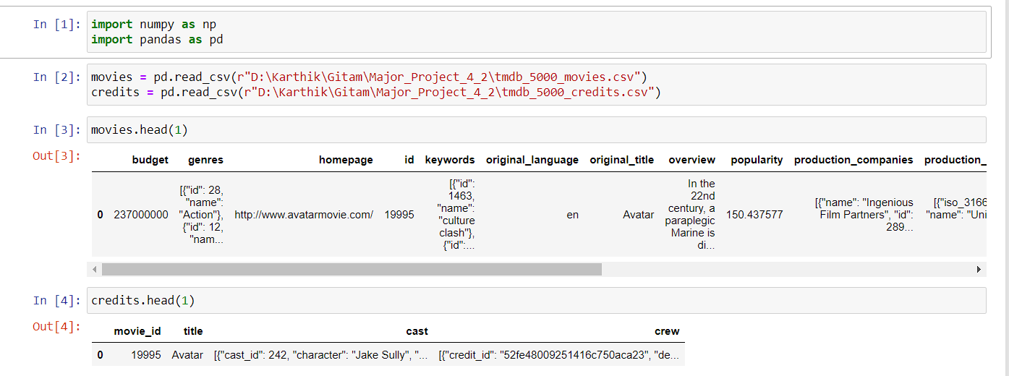

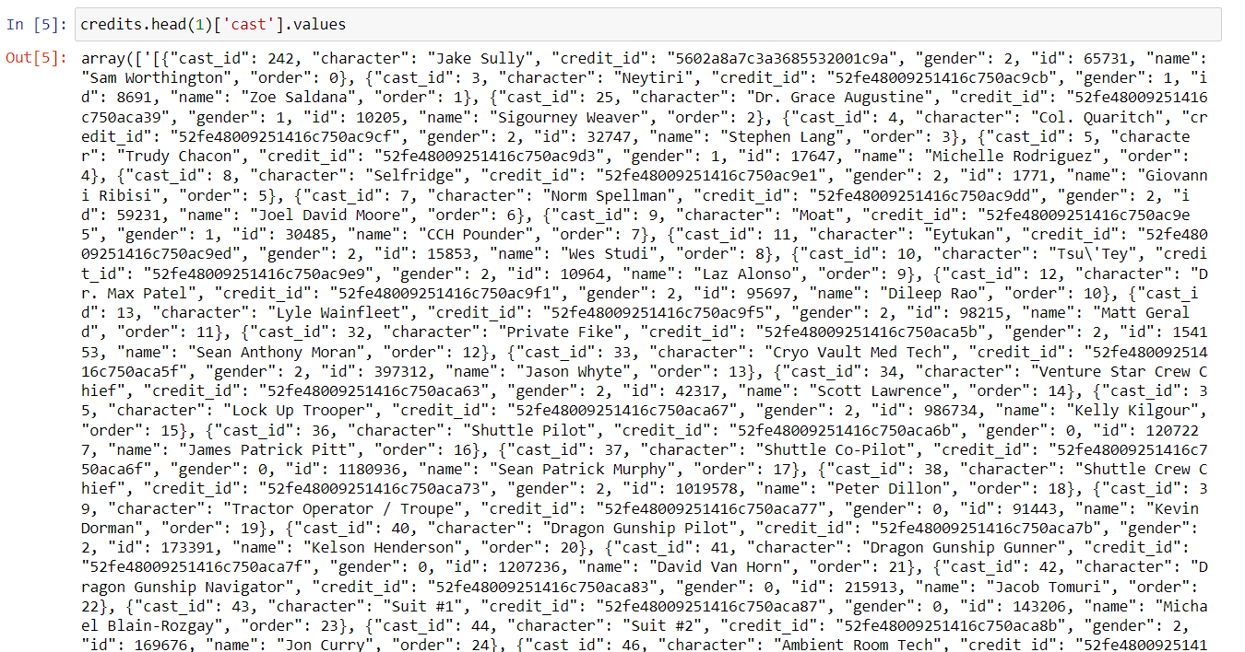

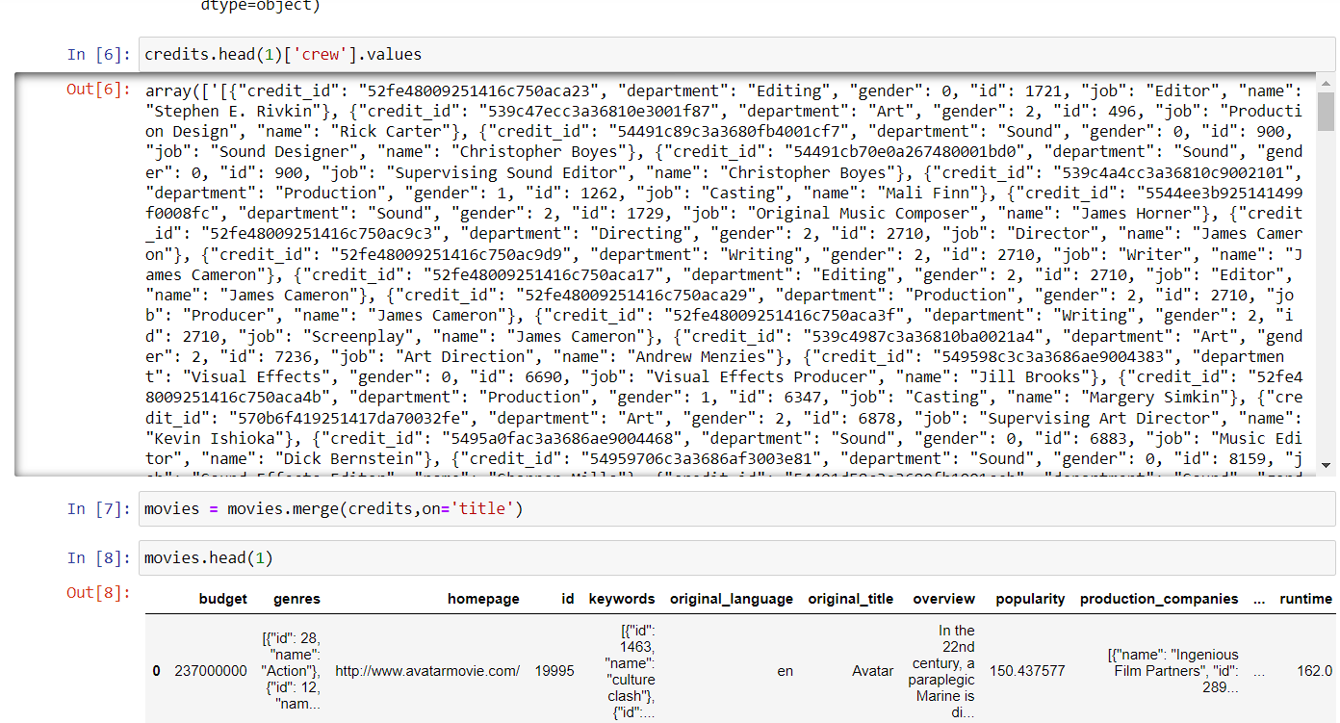

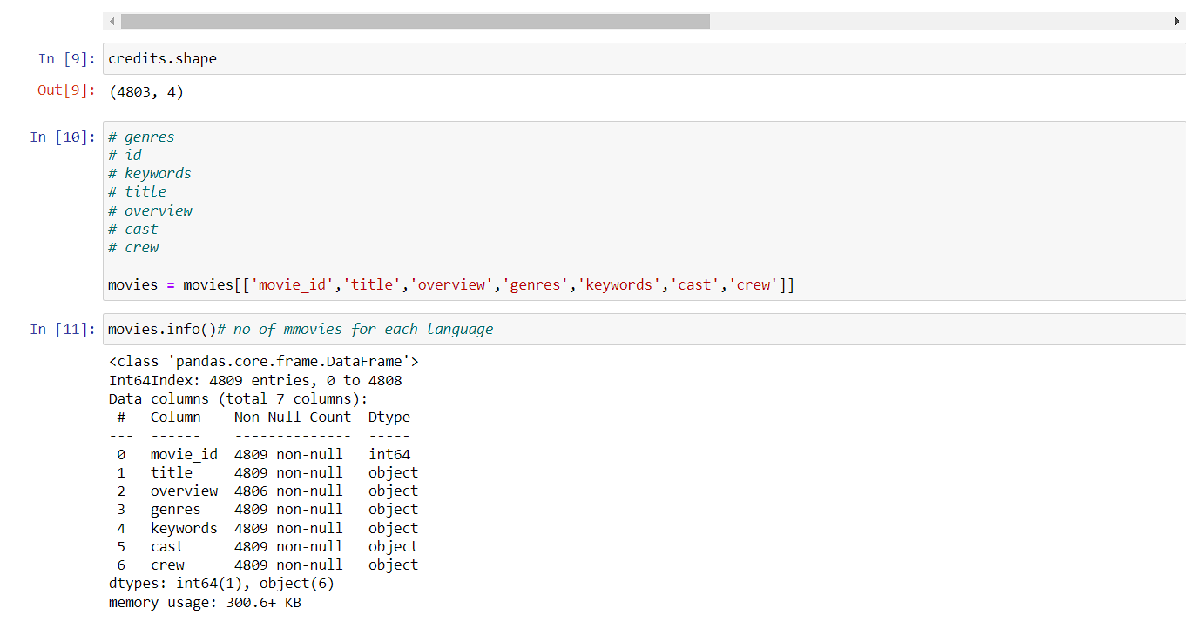

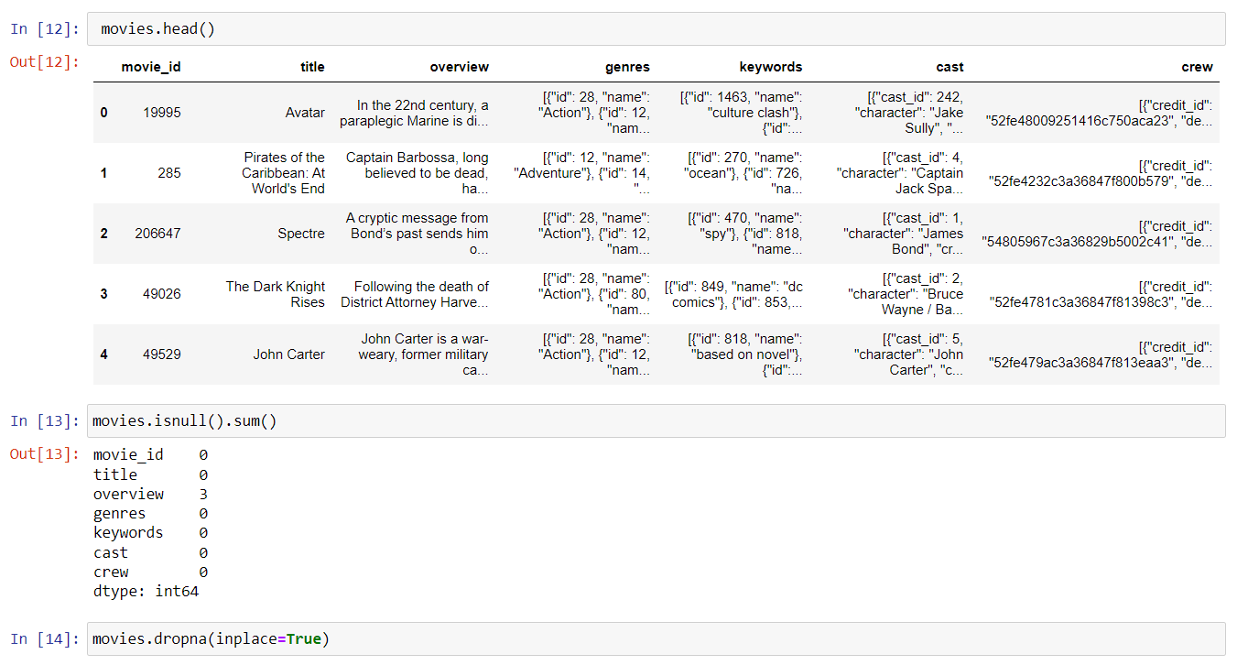

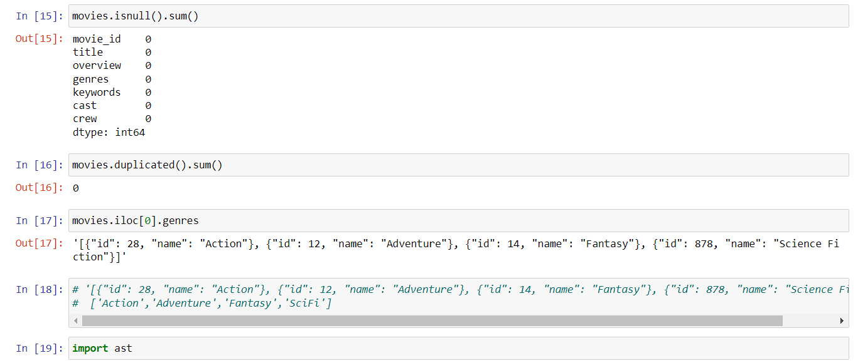

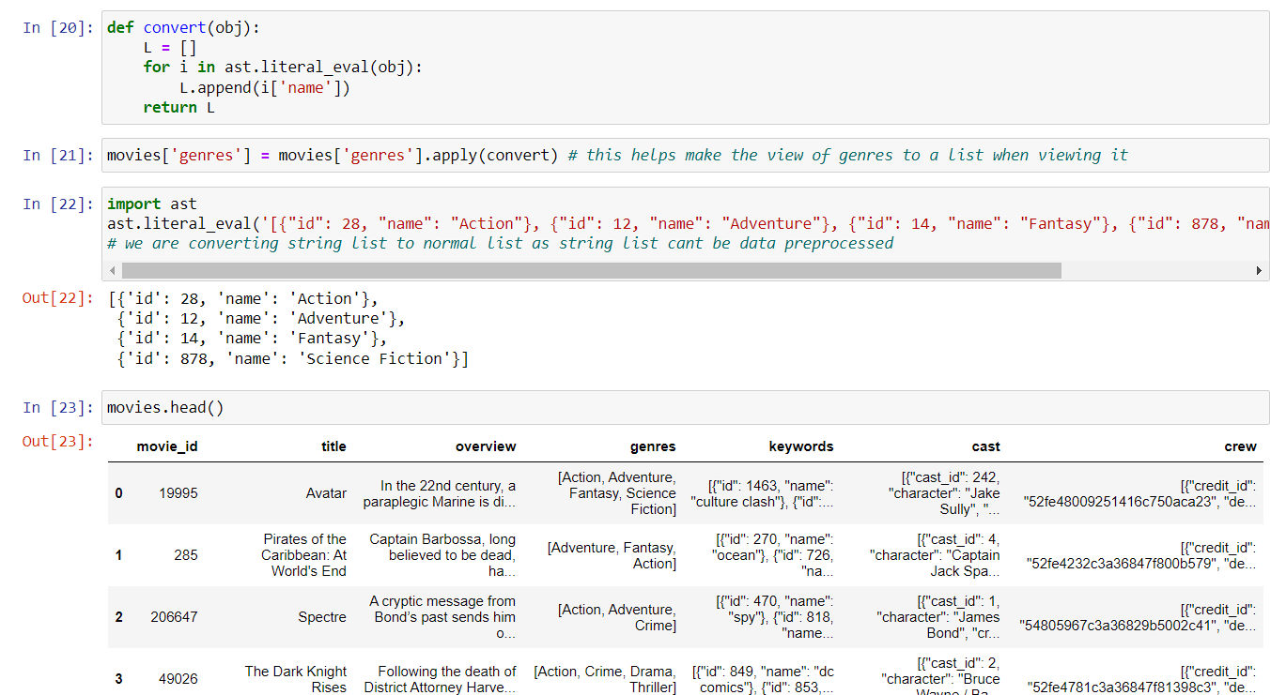

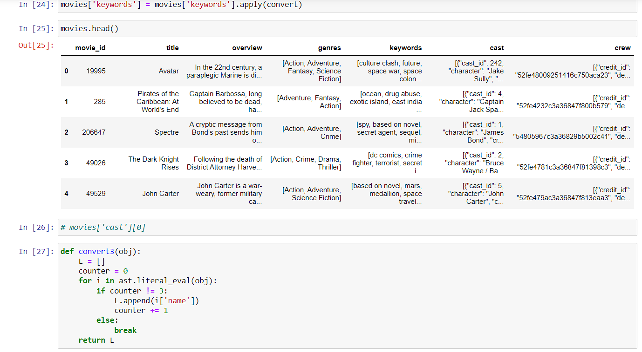

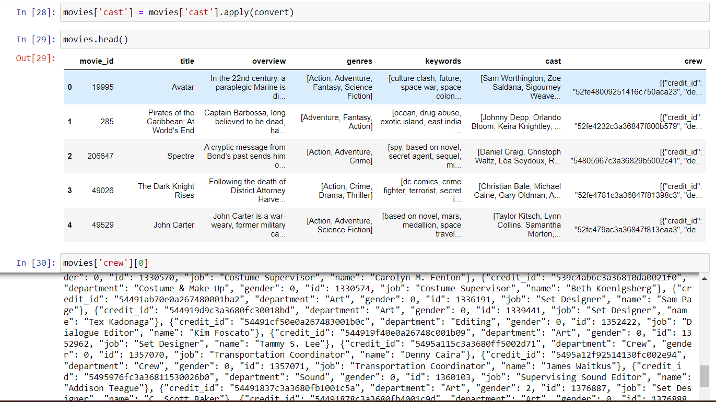

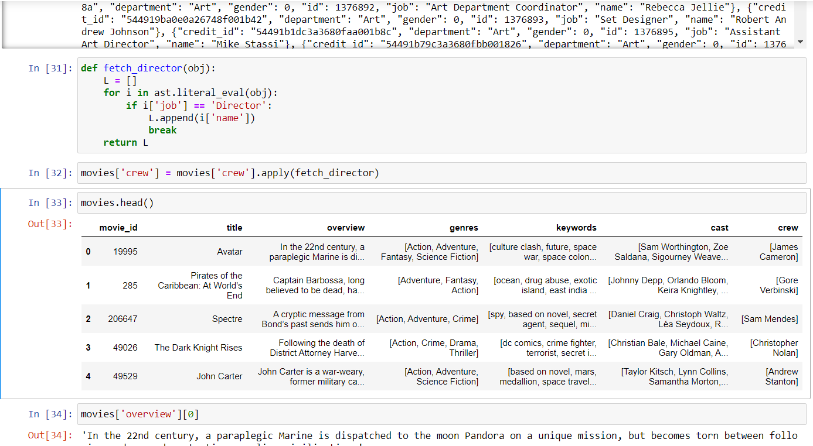

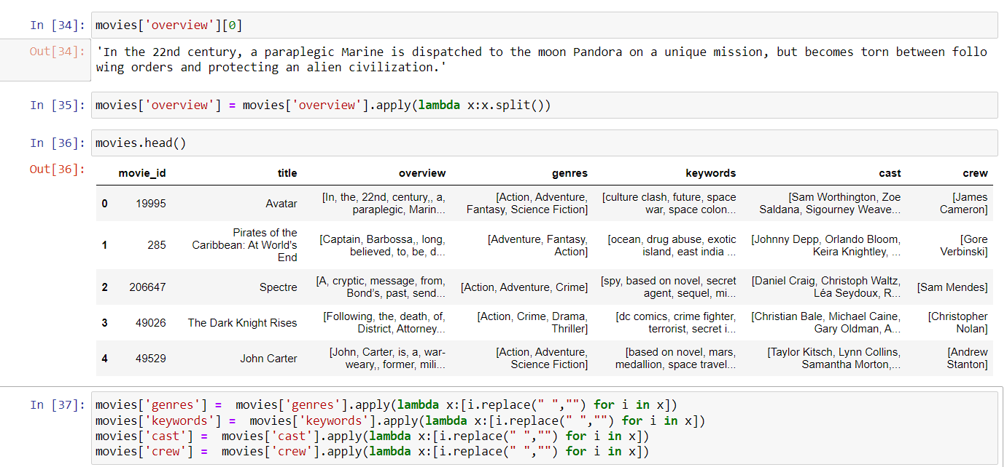

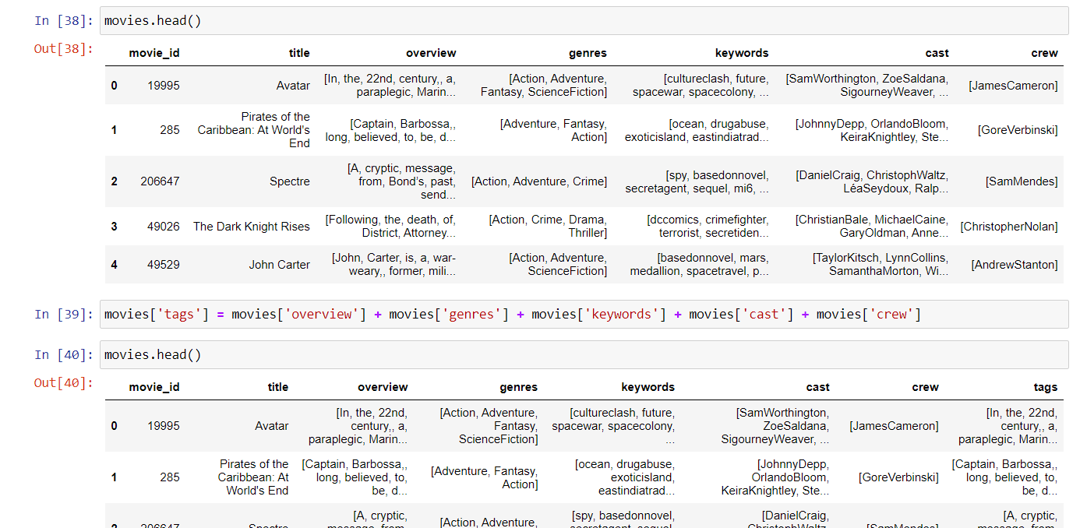

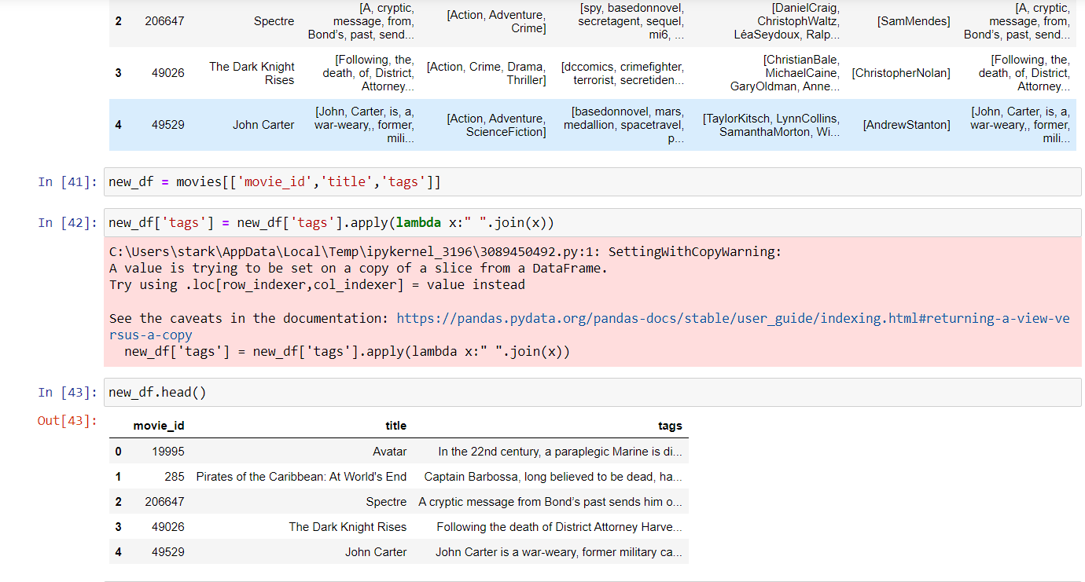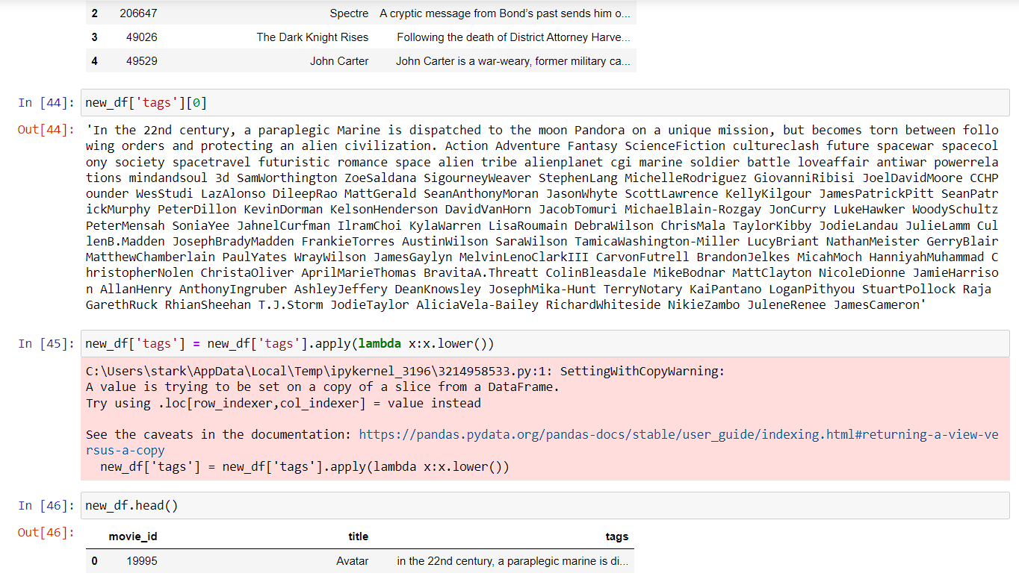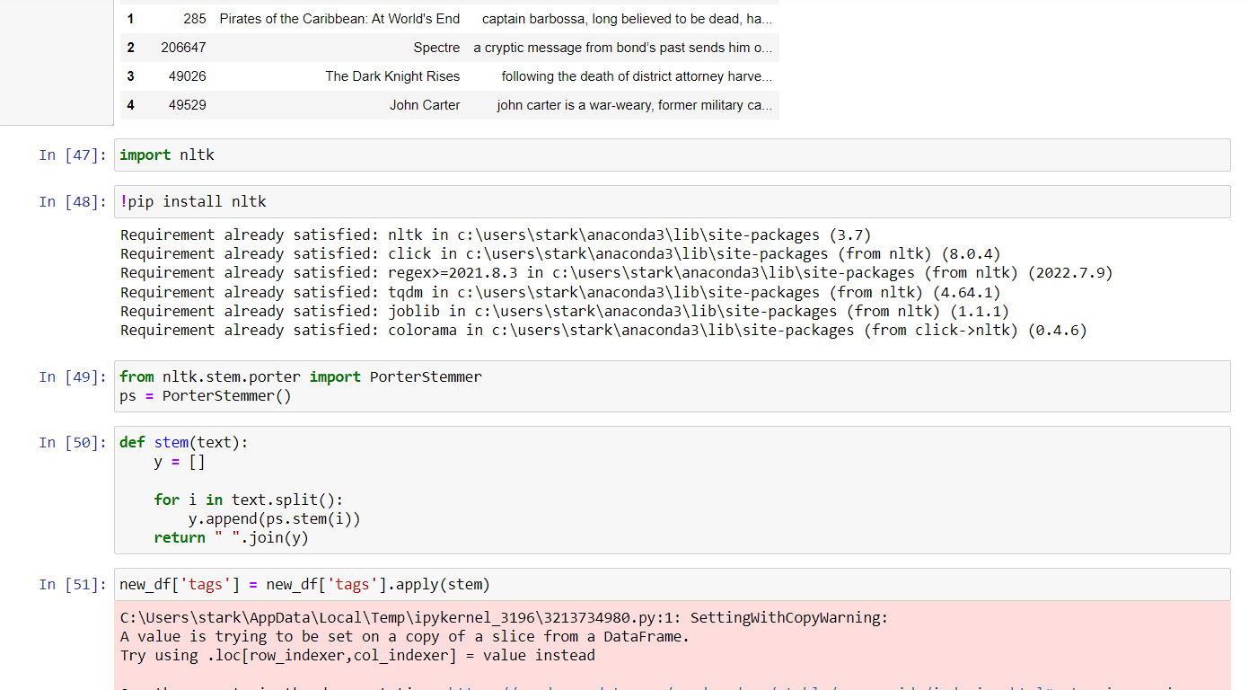

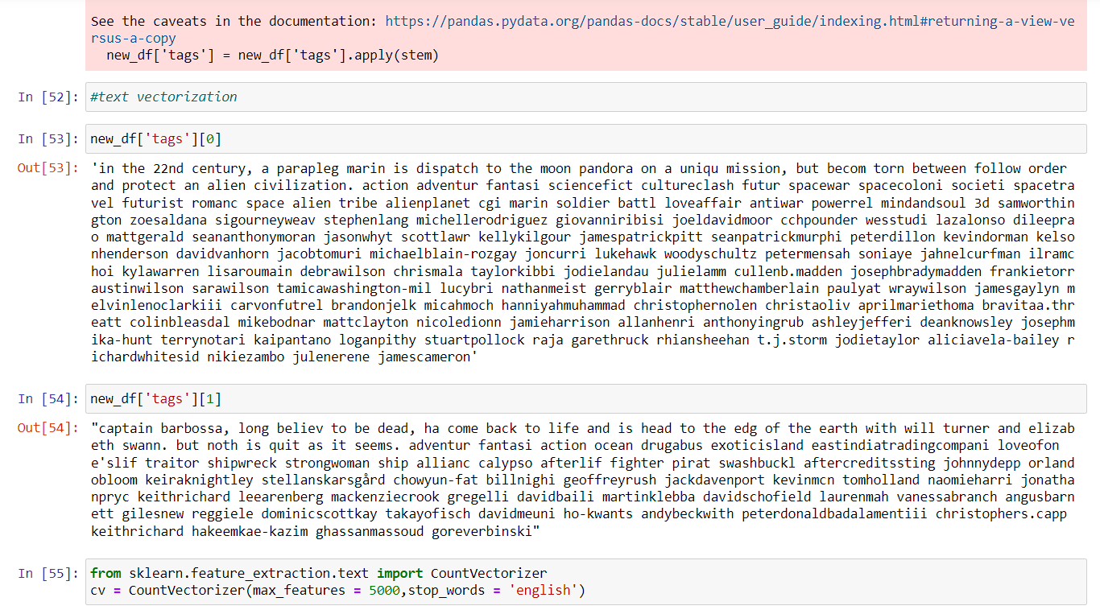

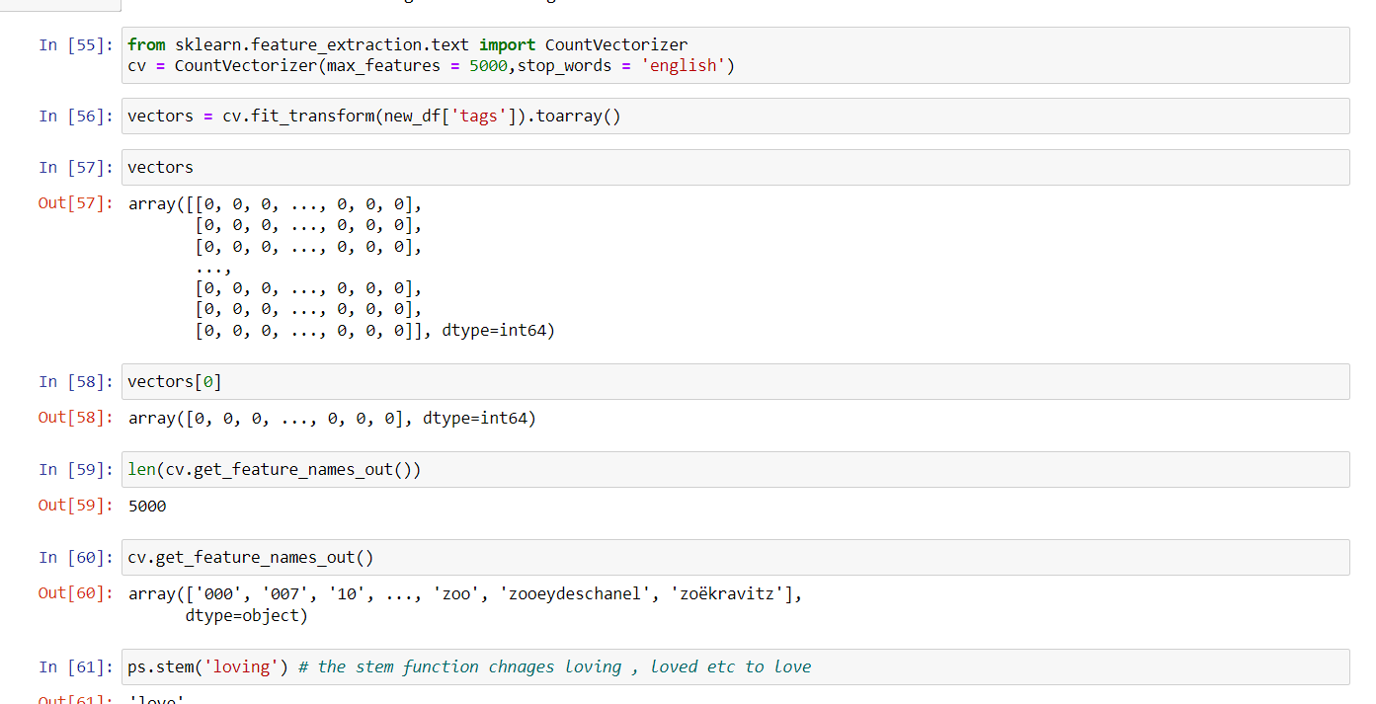

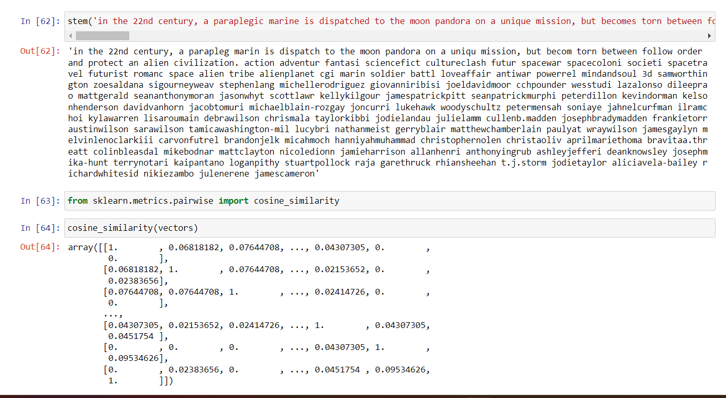

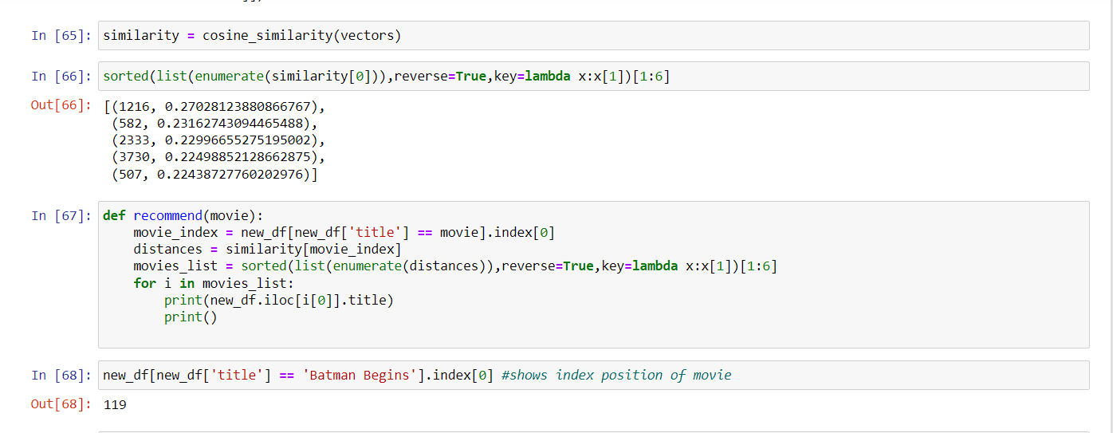

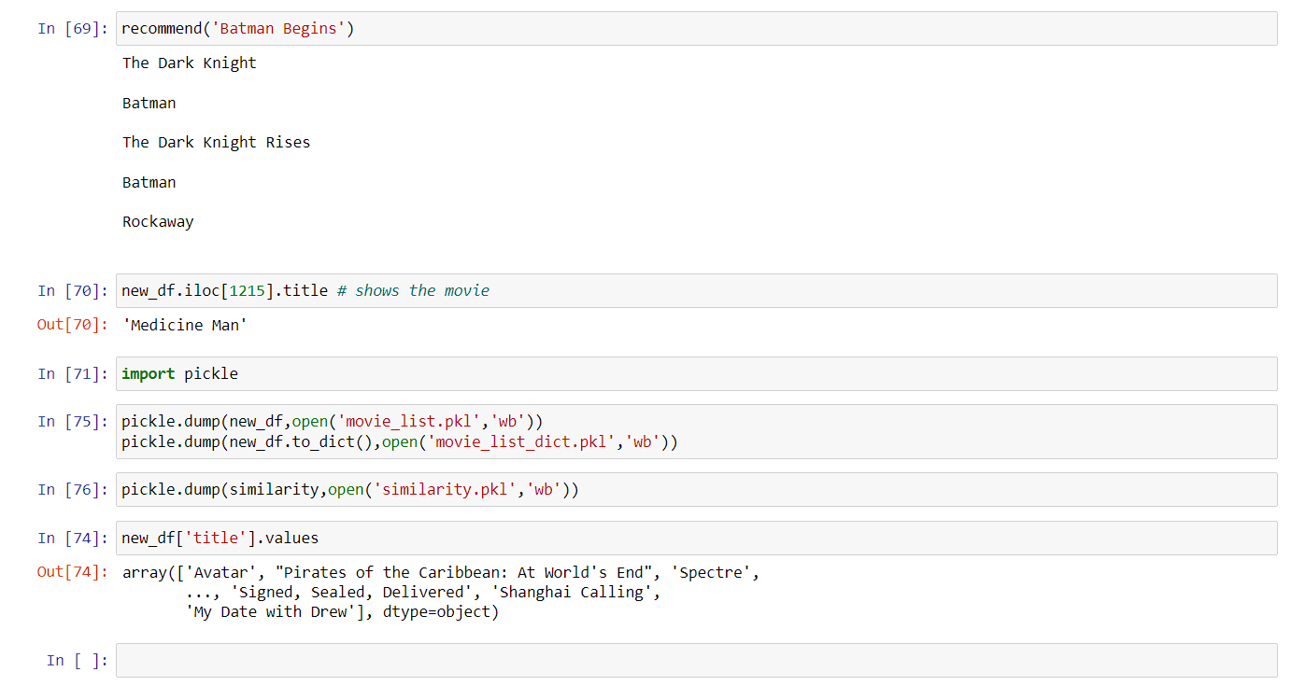

**VS CODE or Pycharm Code:**

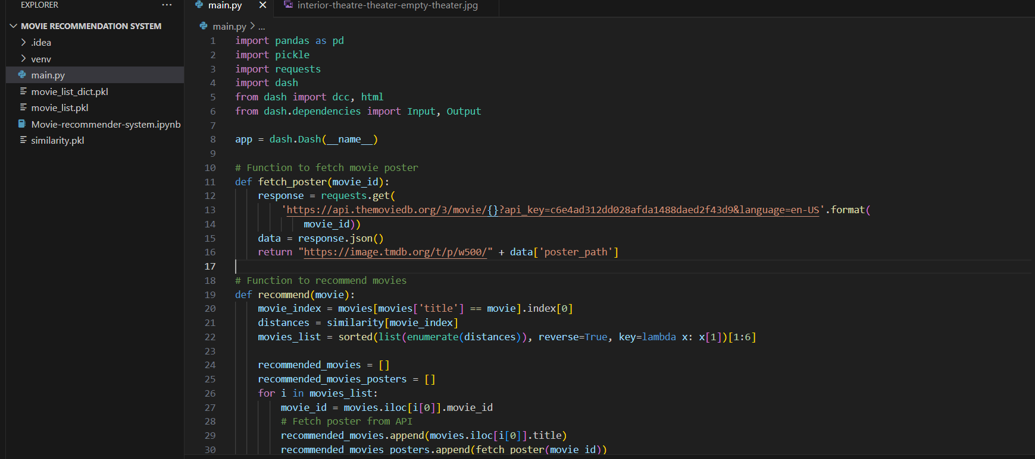

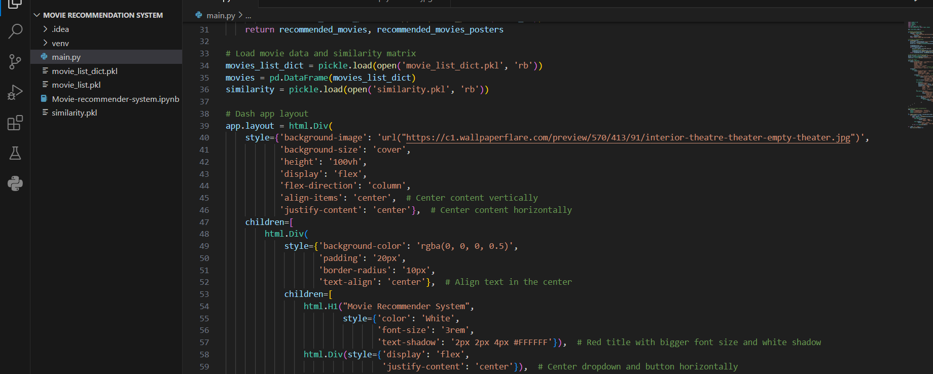

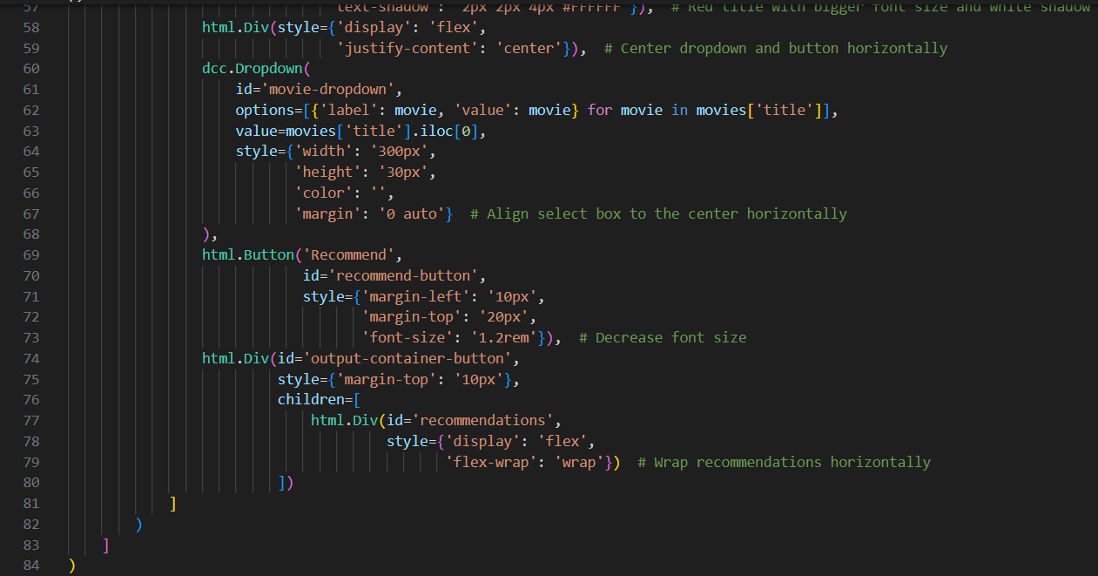

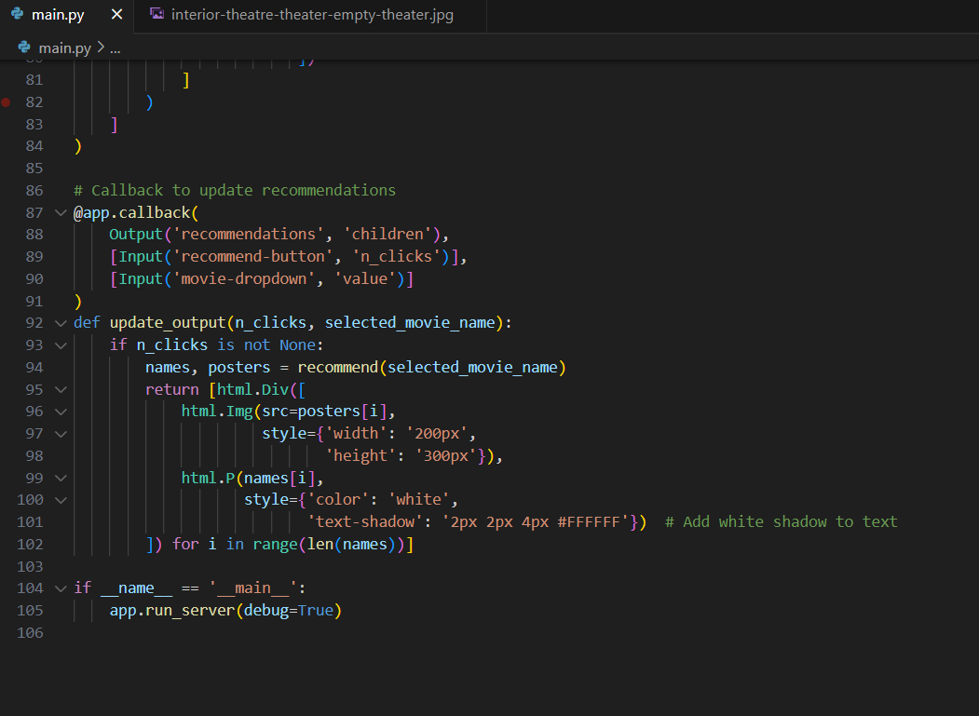

**8.4 Outputs :**

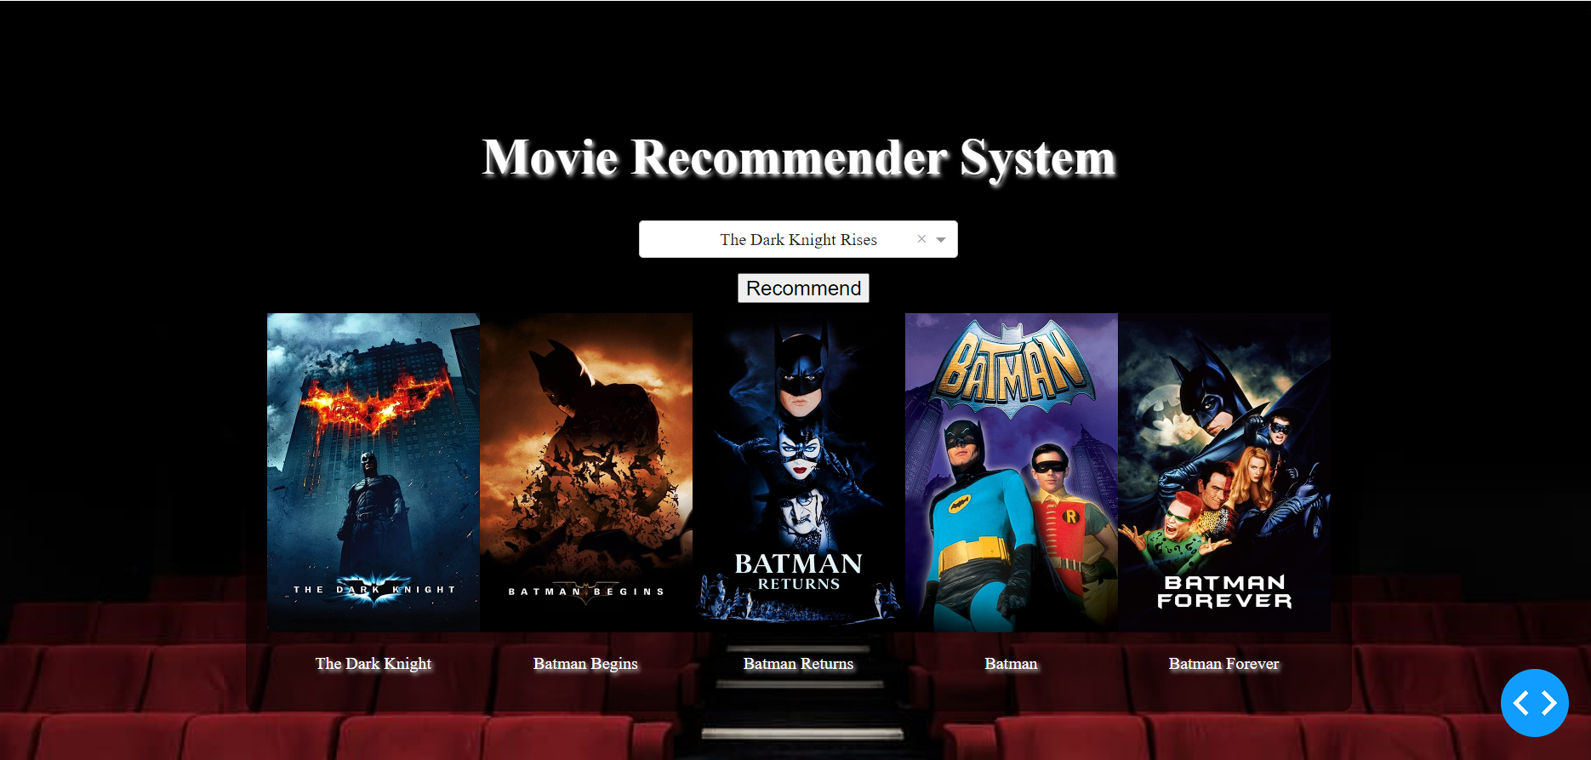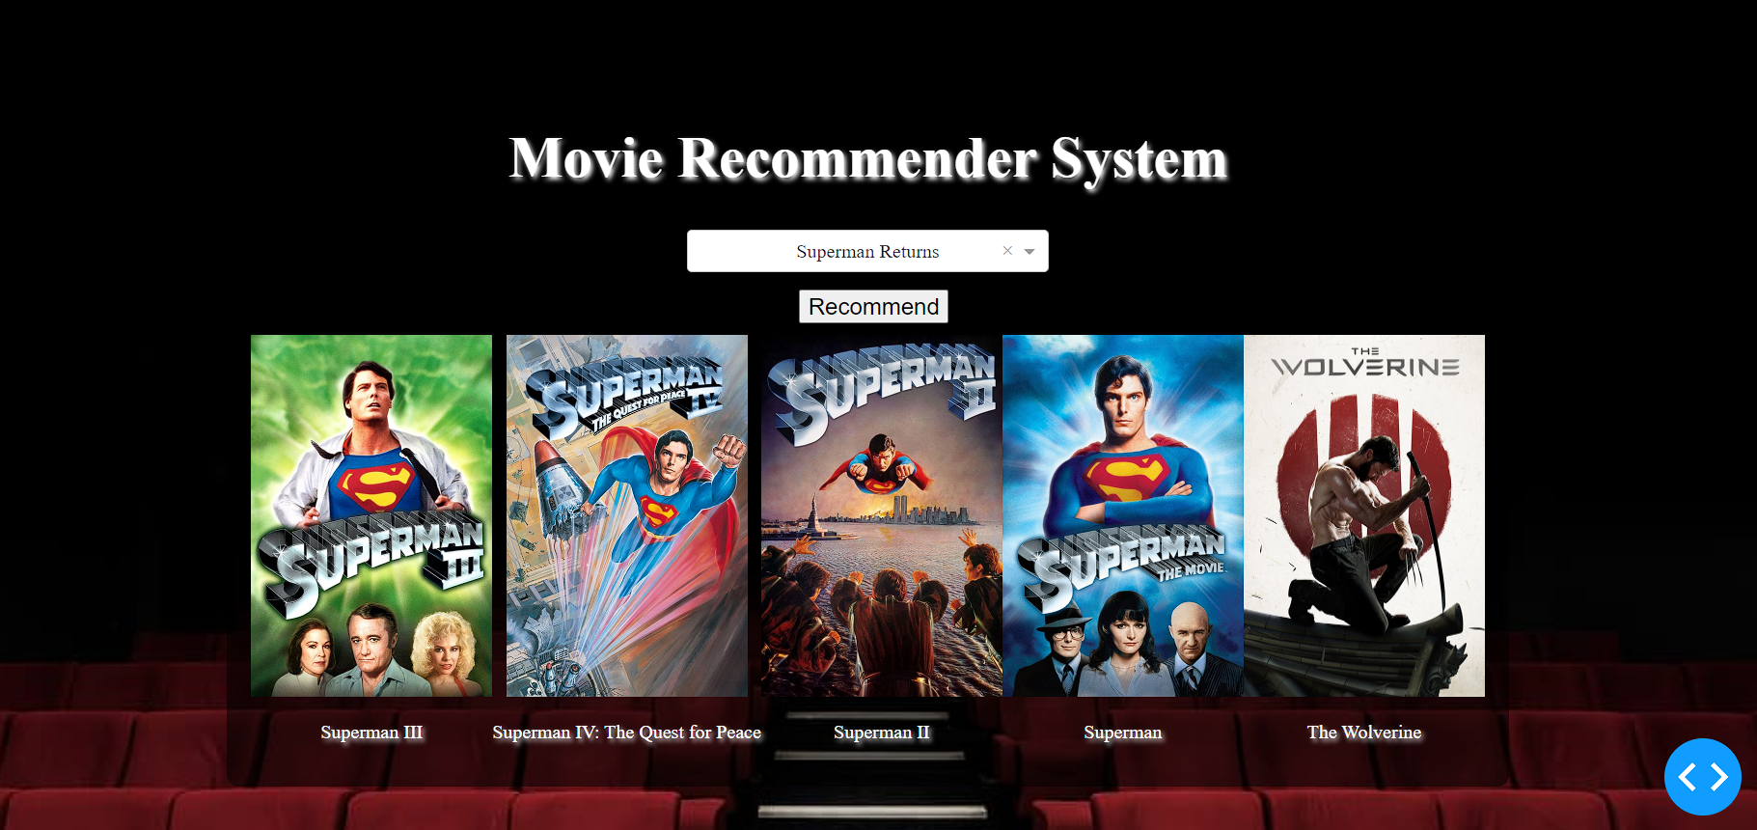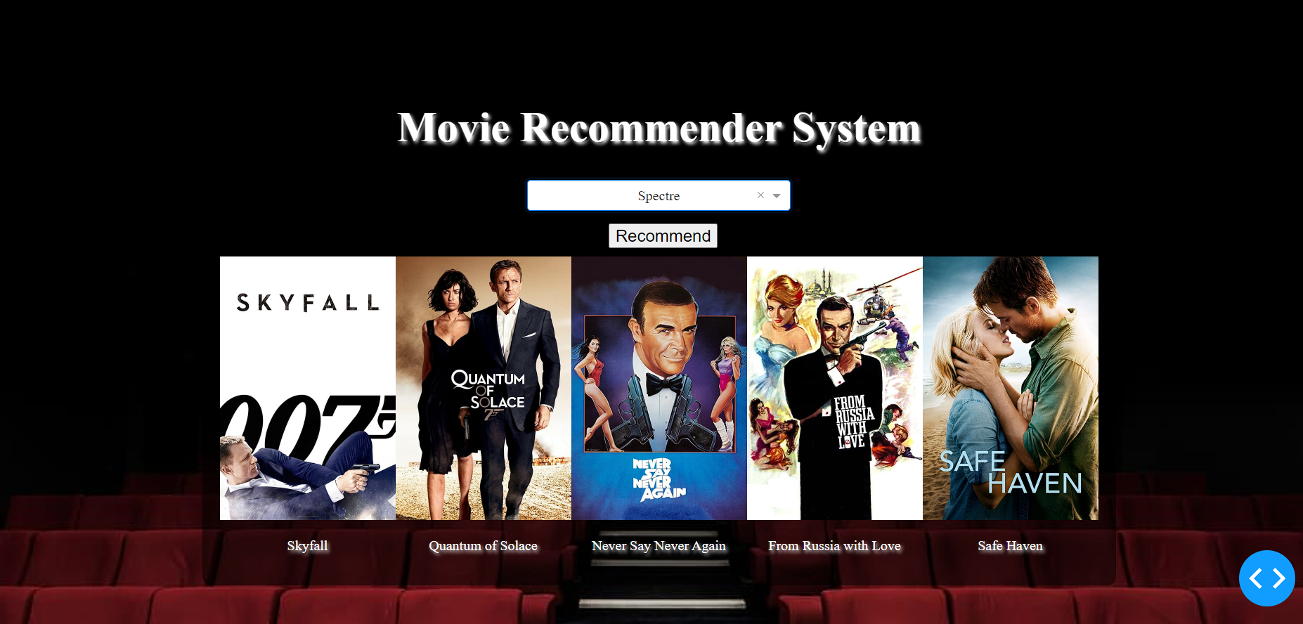

**9. Deployment**

Deploying your movie recommendation project using Ngrok involves a few steps. Ngrok allows you to expose your local server to the internet, making your application accessible remotely. Here's a step-by-step process to deploy your project:

1. **Install Ngrok:** If you haven't already, download and install Ngrok from their website: <https://ngrok.com/download>
2. **Prepare your Project:** Ensure your movie recommendation project is running locally on your machine. Make sure your project is configured to run on a specific port. For example, if your project runs on port 5000, ensure it's configured accordingly.
3. **Run your Project Locally:** Start your movie recommendation project locally on your machine. Make sure it's running smoothly.
4. **Expose your Local Server with Ngrok:** Open a terminal or command prompt. Navigate to the directory where Ngrok is installed. Run the following command to expose your local server to the internet: **ngrok http <port>**
5. **Access your Project via Ngrok URL:** After running the Ngrok command, it will display a forwarding URL, usually starting with http:// or https://. Copy this URL and share it with others or use it to access your project remotely. Keep in mind that this URL will only be active as long as Ngrok is running. If you close Ngrok, the URL will no longer work.
6. **Test your Project:** Open a web browser and paste the Ngrok URL. Ensure that your movie recommendation project is accessible and functions correctly via the Ngrok URL.
7. **Keep Ngrok Running:** Keep the Ngrok terminal window open to maintain the tunnel to your local server. If you close the Ngrok terminal window, the tunnel will be closed, and the Ngrok URL will become inactive.
8. **Optional:** Configure Ngrok Authtoken: You can sign up for a free Ngrok account and obtain an authtoken to have more control over your tunnels, such as custom subdomains and longer session times. You can set up your authtoken by running: **ngrok authtoken <your-authtoken>**

By following these steps, you should be able to deploy your movie recommendation project using Ngrok and make it accessible over the internet.

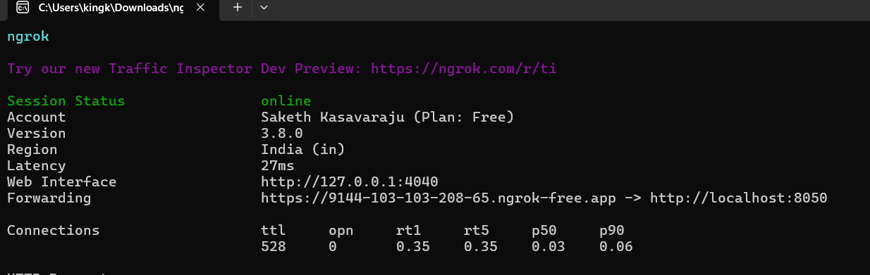

**Fig 9.1 : Ngrok Commands**

**10 . CONCLUSION**

In conclusion, the movie recommender system project, powered by the Dash library, represents a significant stride in providing users with an intuitive and engaging platform for discovering movie recommendations. By harnessing data sourced from The Movie Database (TMDb) API and employing a pre-calculated similarity matrix, the system adeptly suggests relevant movies based on the user's preferences. The utilization of the Dash framework has proven instrumental in crafting a highly responsive web application. Through its versatile features, including interactive dropdown menus and buttons, Dash enables seamless user interaction, fostering an intuitive and enjoyable exploration of movie recommendations. Moreover, the integration of external APIs for retrieving movie posters contributes to the system's visual allure, enhancing the overall user experience. This visual augmentation not only enriches the presentation of movie recommendations but also adds a layer of aesthetic appeal that captivates users. In essence, this project serves as a testament to the efficacy of Dash in developing interactive web applications. It underscores the platform's capability in facilitating the creation of user-friendly interfaces that seamlessly integrate with diverse data sources and external APIs. Furthermore, the project underscores the immense potential of recommender systems in delivering personalized content recommendations. By leveraging sophisticated algorithms and rich datasets, such systems can cater to individual preferences, offering users a curated selection of content tailored to their tastes. Overall, this endeavor not only showcases the technical prowess of Dash in web development but also underscores the transformative impact of recommender systems in enhancing user engagement and satisfaction. Through its seamless interface and personalized recommendations, the movie recommender system project sets a benchmark for delivering immersive and tailored experiences in the realm of content discovery.

**REFERENCES**

[1] R. K. Sarala and K. Manojkumar, "A survey on recommendation system techniques," in 2021 3rd International Conference on Inventive Research in Computing Applications (ICIRCA), 2021, pp. 366-371.

[2] G. Adomavicius and A. Tuzhilin, "Toward the next generation of recommender systems: A survey of the state-of-the-art and possible extensions," IEEE Transactions on Knowledge and Data Engineering, vol. 17, no. 6, pp. 734-749, 2005.

[3] Y. Koren, R. Bell, and C. Volinsky, "Matrix factorization techniques for recommender systems," Computer, vol. 42, no. 8, pp. 30-37, 2009.

[4] B. Sarwar, G. Karypis, J. Konstan, and J. Riedl, "Item-based collaborative filtering recommendation algorithms," in Proceedings of the 10th international conference on World Wide Web, 2001, pp. 285-295.

[5] M. Deshpande and G. Karypis, "Item-based top-n recommendation algorithms," ACM Transactions on Information Systems (TOIS), vol. 22, no. 1, pp. 143-177, 2004.

[6] X. Su and T. M. Khoshgoftaar, "A survey of collaborative filtering techniques," Advances in artificial intelligence, vol. 2009, 2009.

[7] J. L. Herlocker, J. A. Konstan, A. Borchers, and J. Riedl, "An algorithmic framework for performing collaborative filtering," in Proceedings of the 22nd annual international ACM SIGIR conference on Research and development in information retrieval, 1999, pp. 230-237.

[8] N. Jain, M. Patel, and S. Patel, "Movie Recommendation System using Content Based Filtering," International Journal of Computer Applications, vol. 179, no. 30, pp. 32-35, 2018. [Online]. Available: <https://www.ijcaonline.org/archives/volume179/number30/jain-2018-ijca-917182.pdf>

[9] Plotly Dash User Guide, "Dash HTML Components," Plotly, [Online]. Available: <https://dash.plotly.com/dash-html-components>

[10] Plotly Dash User Guide, "Dash Core Components," Plotly, [Online]. Available: <https://dash.plotly.com/dash-core-components>

[11] Dash Deployment Server Documentation, "Deploying with ngrok," Plotly, [Online]. Available: <https://dash.plotly.com/deployment>

[12] S. Khan, "How to Deploy Your Dash App to the Internet in Minutes with Ngrok," Data Professor, 2020. [Online]. Available: <https://www.youtube.com/watch?v=BqqbU40cPbM>

[13] J. E. Gentle, "Deploying a Dash app with Ngrok," Towards Data Science, Medium, 2019. [Online]. Available: <https://towardsdatascience.com/deploying-a-dash-app-with-ngrok-b2a578b642d7>

[14] M. A. Alshehri, "Movie Recommendation System Using Content-Based Filtering Technique," Journal of Computer Science, vol. 15, no. 6, pp. 840-849, 2019. [Online]. Available: https://thescipub.com/pdf/jcssp.2019.840.849.pdf

[15] D. V. Sunitha and K. N. H. Gowda, "Movie Recommendation System Using Content Based Filtering," International Journal of Computer Sciences and Engineering, vol. 5, no. 9, pp. 1705-1710, 2017. [Online]. Available: https://www.researchgate.net/publication/320572649_MOVIE_RECOMMENDATION_SYSTEM_USING_CONTENT_BASED_FILTERING